Ventilation systems
Algebra and functions
Simultaneous equations: analytical solution by substitution of one linear and one
quadratic equation.
Context
Most modern buildings need ventilation of some form: fresh air input for offices and shops, extraction systems for kitchens, restaurants, and gyms. Often the air has to be taken through a duct to or from the outside of the building.
In order to force air to flow through a duct, it has to be blown or sucked – there must be a difference $p$ between the pressures at opposite ends of the duct. For straight ducts, the magnitude of the difference is proportional both to the square of the required volumetric flow $V$ and to the length $L$ of the duct.
$$p(V,L)={\text{kLV}}^{2}$$
Any change in the cross-section of the duct, or its direction (e.g. inlet or exhaust terminals, bends, etc.) requires an additional pressure difference to maintain the air flow. This is again proportional to the square of the flow.
$$p(V)={\text{cV}}^{2}$$
The pressure in the duct will therefore depend on position. A typical profile is shown below – the fan sucks the stale air from a room, and blows it into the atmosphere:
Fig 1
Typical profile of pressure with distance along a ventilation duct
Fans for use in ducted ventilation systems can be characterised by the air flow $V_{f}(p)$ that they will produce against a given pressure difference $p$. Consequently the performance of a particular combination of fan and duct system will be determined by finding the values of pressure $p$ and flow $V$ that simultaneously satisfy the following two conditions:
$p=$ total pressure difference required for duct and terminals to deliver a flow $V$
$V=$ flow delivered by fan working against a pressure difference $p$

Problem
A ducted ventilation system is needed to remove stale, moist air from the changing room of a village hall after footballers have showered. The recommended ventilation rate is 15 to 20 air changes per hour [1, p.4; 2, Table1], which, for a room volume 41 m³, gives a minimum target air flow of 615 m³/h. To keep the mean air velocity in the fan duct below the preferred figure of 8 m/s [2, Table 1], the duct diameter $d$ must satisfy:
$$\begin{aligned}{\text{615}}/({\text{3600}×{πd}^{2}}/4)≤8 \\ d≥{\left((4×\text{615})/(8×\text{3600}×π)\right)}^{\frac{1}{2}}=0\text{.}\text{165}\text{ m}\end{aligned}$$
The next larger standard size is 200 mm, and for this duct, the mean air velocity for the target flow is
$$8×(0\text{.}{\text{165}}/0\text{.}2)^{2}=5\text{.}\text{44} \text{m/s}$$
Unfortunately , this is larger than the recommended value for extraction terminals [2, Table 1], so the flow needs to be split between two separate extraction terminals, and then joined by a ‘Y’-piece just prior to the fan.
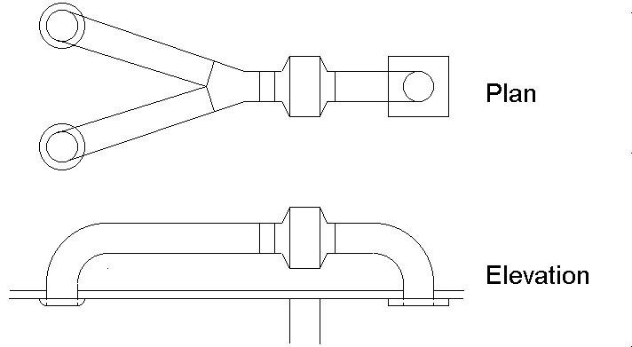
Fig 2
Plan and elevation of ventilation duct with two extraction branches
With this arrangement, the flow in each branch is half that in the main duct, reducing the associated pressure drops by a factor four. These are indicated by asterisks in the following table, which gives the pressure coefficients for all the components in the system:
Component  Table 1  Pressure coefficients for components of a ventilation duct. | Pressure drop (Pa) for 1 m length and  flow 1000 m³/h in main duct | Pressure drop (Pa)  for flow 1000 m³/h in main duct
Extract terminal * |  | 156 *
90º bend * |  | 5 *
1.5 m straight duct * | 2.5 * | 4 *
‘Y’-piece |  | 19
0.5 m straight duct | 10 | 5
90º bend |  | 21
Exhaust terminal |  | 66
Total |  | 276

So, for a flow of 615 m³/h , the total pressure drop is 276 x (0.615)² = 104 Pa.
The performance chart below [1, p.109] shows that the point (615, 104) is inside the performance envelope of the recommended ACM200 fan, which can therefore deliver the target flow.
Fig 3
Performance of
Vent-Axia ACM200 mixed-flow fan (with operating curve for duct system)
To determine what actual ventilation can be achieved, write $v$ for the normalised flow $V/{\text{1000}}$, so that
$p=\text{276} v^{2}$.
This relationship is the system operating curve for flow in the duct, and is shown in green on the above chart. As the flow increases, so the pressure will increase, until, at the point where the curves intersect, the fan reaches its performance limit. To determine the intersection, note that for static pressures between 0 and 220 Pa, the flow rate for the fan (in m³/h ) is given approximately by
$$V=\text{778}−1\text{.}\text{14}p$$
Approximation
Straight-line fitting
or, equivalently,
$$v=0\text{.}\text{778}−0\text{.}\text{00114}p$$
Substituting for $p$ gives a quadratic equation for $v$:
Algebra and functions
Solution of simultaneous linear and quadratic equations
$$v=0\text{.}\text{778}−0\text{.}\text{3146}v^{2}$$
i.e.
$$v^{2}+3\text{.}\text{178}v−2\text{.}\text{473}=0$$
with positive solution $v=0\text{.}\text{646}$. This corresponds to a flow rate 646 m³/h, or
15.7 air changes per hour, 5% better than the target.
Modelling
Interpretation of results in problem domain
For comparison, it is interesting to calculate the performance that would result if the advice to split the extract duct is ignored. In this case, the total pressure coefficient is 752, and the corresponding quadratic equation is:
$$v^{2}+1\text{.}\text{166}v−0\text{.}\text{9075}=0$$
with positive solution $v=0\text{.}\text{534}$. This gives a flow rate 534 m³/h, just within the range of validity of the linear approximation to the performance curve of the fan. The corresponding ventilation is 13.0 air changes per hour, 14% below the target, and 17% less than the performance of the recommended configuration.
Sources
- Vent-Axia Domestic and Commercial Ventilation Product Range 2001/2002
- Your Vent-Axia System Calculator, PDF document downloadable from Vent-Axia website www.vent-axia.com , Revision date 1997

