MATHEMATICS – WHAT USE IS IT?

Mathematics in the Electronics Systems Industry
Marconi Electronic Systems develop and produce systems for military and civil use. Examples are to be found in Type 23 frigates and in Tank gunnery simulators, and from Airport information display units to Boeing 777 flight computers.

Stress Analysis for Fuel Boost Pump
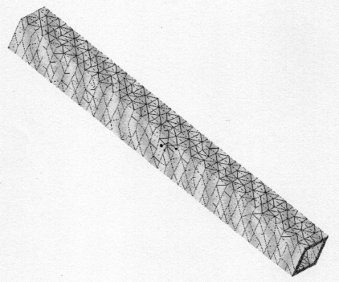
Marconi manufactures pumps that take the fuel to the engines of Boeing 777 aeroplanes. These must be designed so that they are strong enough to take the loads applied without failure. This involves Structural Analysis by Finite Element Method.

A typical beam element looks like this:
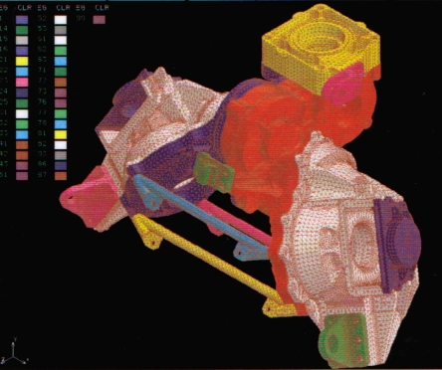
The Volume is filled with Tetrahedral Elements
Large Finite Element model of an Actuator

f₁.v₁
f₂.v₂

I

J

m₁.θ ₁
m₂.θ ₂

Forces and moments can only be applied at the nodes of the beam element (I and J above), not between the nodes. The nodal forces and moments, f_{E} , are related to the nodal rotations and displacements through the element Stiffness matrix K_{E}.

In matrix form f_{E} = K_{E} v_{E} , where

f_{E} = $\left(\begin{matrix}f_{ I} \\ m_{ I} \\ f_{ J} \\ m_{ J}\end{matrix}\right)$ , v_{E} = $\left(\begin{matrix}v_{ I} \\ θ_{ I} \\ v_{ J} \\ θ_{ J}\end{matrix}\right)$ and
f _{I} = vertical shear force applied at local node I.
m _{I} = moment applied at local node I
v _{I} = vertical displacement at local node I
θ _{I} = slope of beam at local node I

Boundary conditions i.e. loads and fixings, have to be applied. The behaviour of the structure can then be deduced from the Stiffness matrix by solving a set of simultaneous equations.

These are solved by matrix methods. When the size of the matrix is not too large, Cramer’s rule using determinants can be used. For complicated structures the Stiffness matrices can be very large and other methods are used which give a compromise between accuracy and computing time.

1. Solve the equations: 3x + 11y – 8z = 90
7x – 15y + 9z = –65
2x + 4y – 12z = 100
2. The non-uniform beam AD has mass 5 kg and length 12 m. It is supported at the point B which is 2 m from A , and the point C which is 4 m from D . The moment of the force F about the point C is 147 Nm.
A B C D

F
G

What is the moment of the force G about the centre of mass of the beam?
5g
(Take g = 9.8)

Spare Parts and Replacement Pumps - 1
When a pump goes wrong, spare parts or a replacement should be readily available. It is important to have the right number of spares in store. If there are too few, and several pumps need replacing at once, then some customers will have to wait while new ones are manufactured. On the other hand, it is expensive to have too many available.
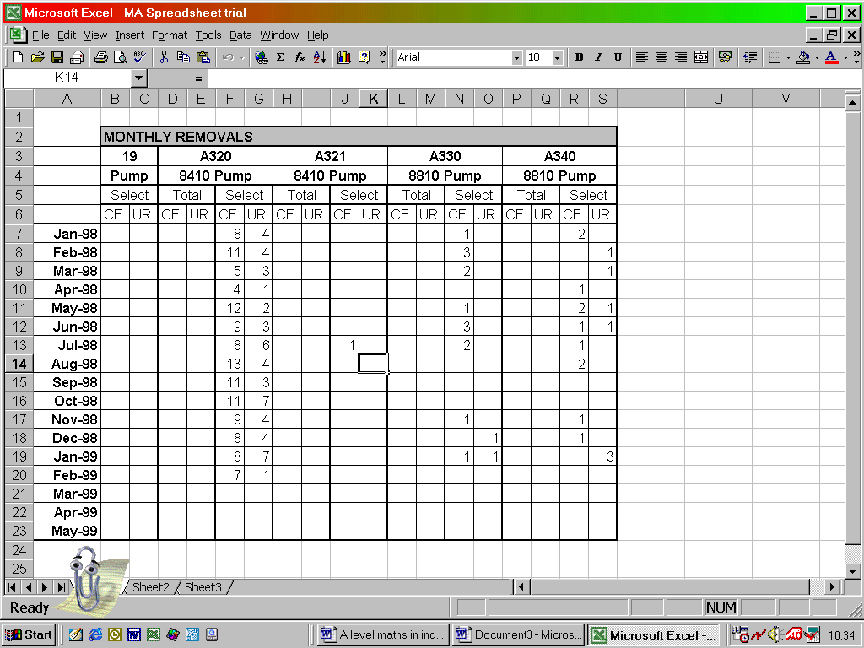
To determine a sensible number of spares involves statistical methods.

Details are collected of all the Confirmed Failures and Unscheduled Removals of pumps from a selected group of airline operators using them each month.

From these is calculated the Mean Time Between Failures (MTBF) , using the formula
MTBF = $\frac{\text{Flying} \text{Hours} × \text{Aircraft} \text{Quantity}}{\text{Number} \text{of} \text{Confirmed} \text{Failures}}$
The failures and unscheduled removals for a six monthly period are taken from a group of selected operators and totalled.
The Failure Rate per 1000 flying hours may then be found by working out 1000 ÷ MTBF, and a typical Failure Trend Chart can then be drawn using a six monthly moving average.

A “trend line” (least squares regression line) has been added to the chart on the right.

3. The information from which the chart on the right was drawn is given in the following table:

Month | 01 | 02 | 03 | 04
Failure Rate | 0.0075 | 0.0073 | 0.0078 | 0.0094

Month | 05 | 06 | 07 | 08
Failure Rate | 0.0092 | 0.0105 | 0.0116 | 0.0120

Month | 09 | 10 | 11 | 12
Failure Rate | 0.0125 | 0.0114 | 0.0114 | 0.0112

Calculate the equation of the regression line of the failure rate on time.
Spare Parts and Replacement Pumps – 2
An expression that can be used for determining the quantity of spare parts that should be in store, based on the reliability of the parts, and obtained from the Poisson distribution, is:

$P = \sum_{n = 0}^{S}{}\frac{(KλT)^{ n} e^{ −λT}}{n !}$
where: P = probability of having a spare part when required (of a particular item type)
S = the number of spare parts carried in stock
K = the quantity of parts used of a particular type
λ = the failure rate
T = time interval

The number of spare parts required can practically be obtained more easily using the nomograph below.

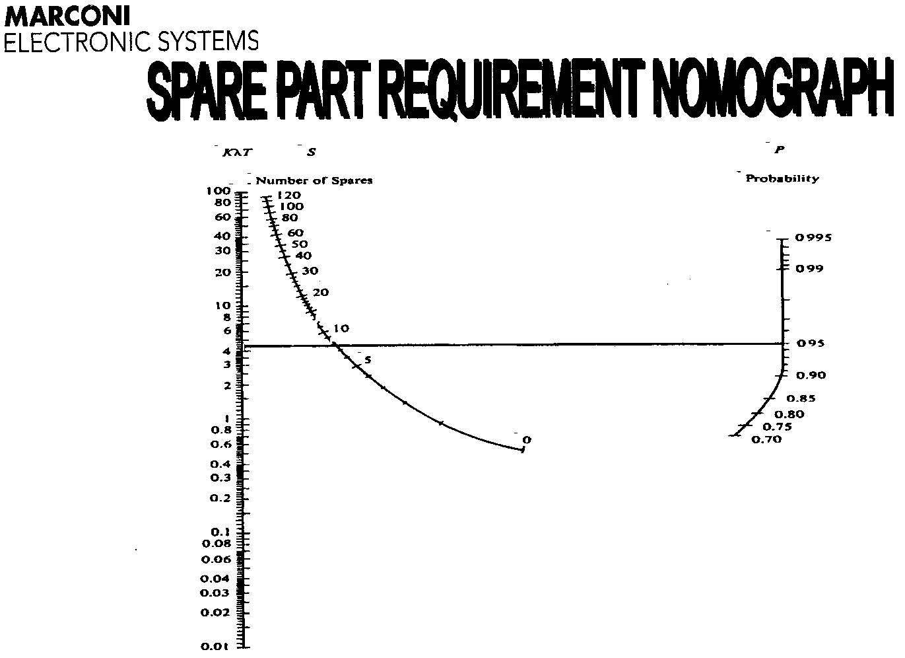

To use this, the value of KλT is calculated from the available data, and the desired probability of having an item in stock is chosen. A straight line is drawn from the KλT axis to the P axis, and the required number of items that should be in store is read off from where this line crosses the S axis.

4. The average number of failures of an electrical component over a six-month period is 1.15. What is the probability that there will be more than five failures of the component during a year?

Answers
1. x = 4 , y = 2 , z = –7
2. 73.5 Nm (the centre of mass is 3 m from B)
3. y = 0.00044685 x + 0.00724545 where x = month , y = failure rate.
4. 0.03 assuming Poisson distribution is suitable.

