Mathematics and Railway Signalling

Railway signalling makes use of a limited number of simple mathematical equations including the equations of motion.

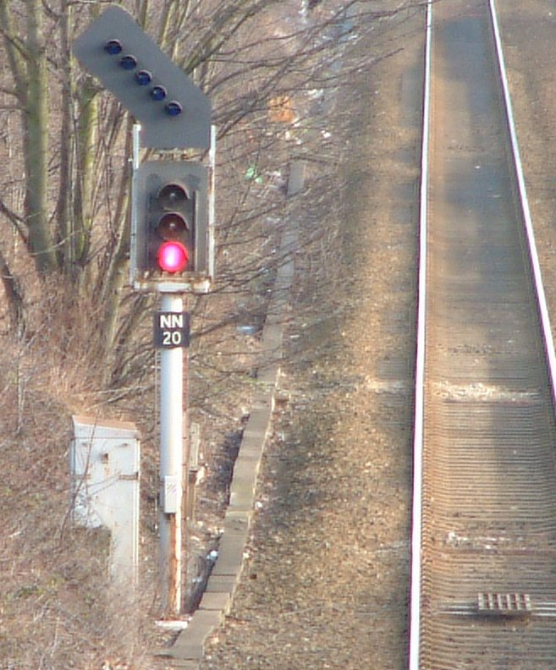 | One of the requirements of signalling is to keep trains separated so that each train has a length of track in front of it that is clear of other trains, enabling it to brake to rest clear of the train in front. This leads to a line capacity issue in the design of the signalling to enable the requisite number of trains to transit the section of the line. The inverse of the number of trains per hour is called the headway. 5 trains per hour, regularly spaced, equates to a headway of 12 minutes. In practice for a specified headway of 12 minutes the signalling would be designed to give a headway of 8 or 9 minutes, to maintain flexibility.

The headway is actually defined as the time between following trains such that the second train runs under clear signals (Green). This is illustrated in Figure 1. The lowest section of the figure indicates the lamps that will be illuminated on a signal, as seen by a driver approaching it (from the left). The distances involved start with an approach distance to the first signal to allow for the driver to observe a clear signal (D1). The next distance is between the first signal and the first warning signal (signal 2) (D2 + D3), followed by distance to the signal protecting the first train (signal 3) (D4 + D5). The next distance is the length of the train so that the rear of the train is past the signal (D7). Also in the UK is the overlap distance past the second signal (D6). This is a distance for a short overrun in the case of a misjudgement of braking. Speed will be taken as v and time as t.

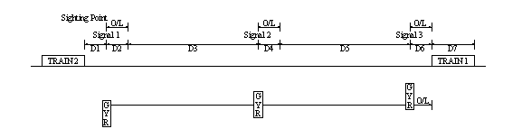

Figure 1

The headway is simply the time taken to cover the total distance, , at the speed of the train. (Speeds in the UK are stated as miles per hour with distances often in metres.) So t = *seconds, where v is the speed in mph.

This formula is true for a simple section of line with no speed changes and no stations. In practice, station stops, speed restrictions and gradients have to be taken into consideration. For the calculations involving changes of speed it is possible to assume a constant braking rate but, for trains, acceleration is not constant; it reduces as the speed rises. It is however possible to have a reasonable approximation to the real values by using a series of constant acceleration rates over, say, a 5 mph band. The resultant curve of acceleration against speed looks about the same. As no two drivers have exactly the same driving characteristics and there is a significant difference depending on the loading of the train, the approximating curve is reasonable.

It is therefore possible to calculate the effects of, say, a speed restriction and as a result to show how the headway changes.

oOo

The first calculation, using the section described above, is for constant speed (no speed restrictions), when the distance between signals is taken as being equal to the braking distance from the maximum permitted line speed. (This is the minimum allowable spacing.)

For a line speed of 60mph the braking distance on level ground is taken as 1065 metres (UK industry standard). The minimum distance between successive signals is therefore 1065 metres. The sighting distance is taken as a nominal 183 metres and the overlap is 180 metres. For a 3 coach passenger train, the train length is 69 metres.

The resulting headway is therefore:
t = (183+1065+1065+180+69)*
t ≈ 96secs. (rounded up)

This is a very straightforward model, but various modifications are required as speed limits and station stops are included.

oOo

Now consider the case where the speed is restricted to 40mph over a distance of 200 metres (over a bridge, or round a sharp curve, for example), starting 400 metres after signal 1. Figure 2 shows this.

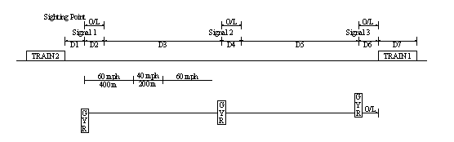

Figure 2

The model must include a realistic deceleration from 60mph to 40mph: 0.5ms⁻². (The m in mph is miles, the m in 0.5ms⁻² is metres!)

We now have
u = 60*
v = 40*
a = -0.5

When these values are substituted into v² – u² = 2as, we find s₆₀₋₄₀ ≈ 400m.

The length of the speed restriction is s₄₀ = 200 metres

To return to the normal running speed for the line, the values for the acceleration will vary as shown below. (Typical values for a class 158 diesel multiple unit.)

40 – 45mph 0.240ms⁻²
45 - 50mph 0.195ms⁻²
50 - 55mph 0.156ms⁻²
55 - 60mph 0.126ms⁻²

Repeated applications of the above formula give
s₄₀₋₄₅ = 177 metres
s₄₅₋₅₀ = 244 metres
s₅₀₋₅₅ = 337 metres
s₅₅₋₆₀ = 456 metres

We also calculate the time through the braking section and each acceleration section, using the formula , rearranged as

t₆₀₋₄₀ = 17.9 sec
t₄₀ = 11.2 sec
t₄₀₋₄₅ = 9.3 sec
t₄₅₋₅₀ =11.5 sec
t₅₀₋₅₅ =14.3 sec
t₅₅₋₆₀ = 17.7 sec

This gives us a total distance and total time for dealing with this restriction of (400 + 200 +177 + 244 + 337 + 456) = 1814 metres and (17.9 + 11.2 + 9.3 + 11.5 + 14.3 + 17.7) = 81.9 seconds. Subtracting this distance from gives the length of track remaining that will be travelled at 60mph. In the example quoted, this is 2562 - 1814 = 748 metres The time for this portion of track is also needed. The new total time is the revised headway. See the spreadsheet which follows. | 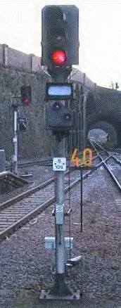

speed | mph |  | 40 | 45 | 50 | 55 | 60
u | m/sec |  | 17.8816 | 20.1168 | 22.352 | 24.5872 | 26.8224
u^2 |  |  | 319.7516186 | 404.6856 | 499.6119 | 604.5304 | 719.4411
 |  | acc | s=(v^2-u^2)/2a | s(rounded) | t=(v-u)/a
 |  | ms^-2 |  | m | secs
acc60-40 |  | -0.5 | 399.6895232 | 400 | 17.8816
acc40-45 |  | 0.24 | 176.9458827 | 177 | 9.313333
acc45-50 |  | 0.195 | 243.4006712 | 244 | 11.46256
acc50-55 |  | 0.156 | 336.2772431 | 337 | 14.32821
acc55-60 |  | 0.126 | 455.9949917 | 456 | 17.73968
 |  | Distance | braking | 400 | 17.8816 | 14.91291
 |  | Distance | accelerating | 1214 | 53 | 45.26068
Distance40 |  |  |  | 200 | 11.18468 | 7.456454
Distance60 |  |  |  | 748 | 27.88714
TOTAL TIME |  |  |  |  | 109.9534

Figure 3

We have an increase in the headway of 14 seconds compared to the previous section. In order to achieve a smooth flow of trains through both sections, and avoid a bottleneck (though this one is minimal!), we might now wish to revisit the first signal section, when we would have to consider spacing the first set of signals further apart so that the run time for them is also 110 seconds. The published headway for this section would probably be considered as 2 min 15 sec or 2 min 30 sec, anyway. For reasons of flexibility, the values quoted will always be on the cautious side. An alternative is to use 4-aspect signals, which means that a following train gets two different “caution” signals before a red signal.

Since the calculations used are all fairly routine, but can also be required to deal with different gradients of the track, as well as permanent and temporary speed restrictions, computers are used. For example, at Hoath Enterprises Limited, we use a programmed spreadsheet, which can carry out the calculations to give tabulated results. Based on this, a graphical representation can then be drawn. For a standard headway calculation, a modification can be made and the whole calculation rerun in about 10 minutes, whereas previously it would have taken several days to complete and check. The graphical representation of a single line track occupancy takes a while longer.

oOo

