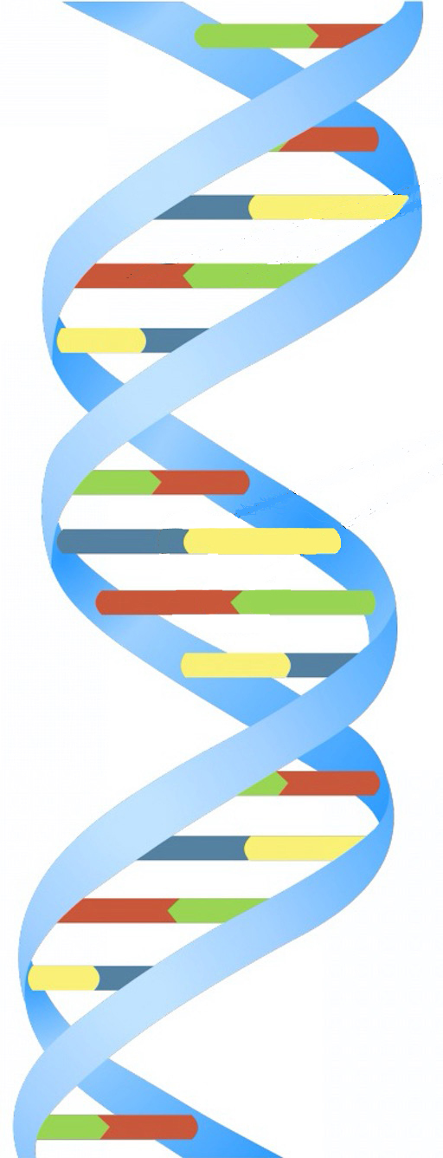
Schools are invited to register an interest in participating in
The Guinness World Record Breaking Largest Ever Maths & Science Lesson
Tuesday 3 November 2015
The Maths and Science of DNA

Thousands of schools around the world in Europe, India, Africa, South America and Asia will take part in this cross curricular 100 minute lesson for learners of ages 9 to 14 on Tuesday 3 November 2015 to set a Guinness World Record for the World’s Largest Maths and Science Lesson. To be part of this exciting event register now at the Bubbly Maths website http://www.bubblymaths.co.uk/ .
From 1st October 2015, free teaching resources, worksheets and teachers notes, including resources for younger and older learners, will be downloadable from http://aiminghigh.aimssec.ac.za and http://www.bubblymaths.co.uk/
The objectives are to create a memorable event where every learner and facilitator enjoys the process of learning mathematics through science and eyes and minds are opened to the relevance of maths and science in real life.
Voluntary contributions can be made through http://www.givengain.com/cause/2173/ to help disadvantaged African children to raise themselves out of poverty through sustainable education – the work of AIMSSEC The African Institute for Mathematical Sciences School Enrichment Centre,
A short video explains DNA and how important it is to every person in the world because DNA determines how each living thing develops, grows, survives, and reproduces as well as what that organism looks like and what diseases it may be susceptible to. Other videos and resources show how to make models of the DNA double helix and each learner will make their own model.
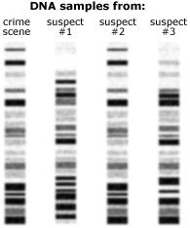
The lesson will be in two parts, to take in total 100 minutes. One part of the lesson must take place on the BIG day Tuesday 3 November 2015.
For the second part of the lesson teachers will be able to choose from a wide range of activities for which videos, worksheets, resources and teachers notes will be provided, to include: problem solving, functions, codes, pattern recognition, measuring, scale, large and small numbers and representation in standard form, sequences, permutations, repeated doubling, multiplying by 10, place value, statistics, the structure and chemistry of DNA, and the use of DNA in identifying characteristics of cells and in forensic science.
After the big lesson, for a class to qualify as participants and get a certificate, teachers must submit one photo of their class with the models they have made as proof of their involvement. The photo and exact numbers of learners and teachers involved, together with the address of the school, must be submitted to http://www.bubblymaths.co.uk/ by Thursday 5 November at the latest. Schools will get a free certificate from AIMSSEC, Bubbly Maths & HeyMath and a template to print certificates for each learner who took part. We hope to achieve a Guinness World Record and feature in the Guinness World Record Book.

