GeoGebra for Beginners – helpsheet

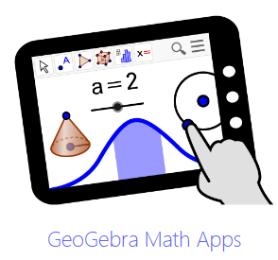
Setting up 1:
Either download GeoGebra or go to the web app at www.GeoGebra.org

Setting up 2:
Select ‘Graphing Calculator’ or ‘Geometry’
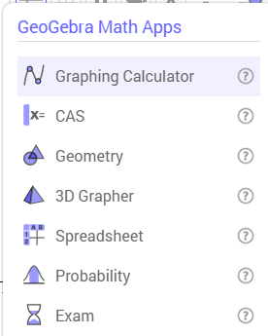

Two menus. On the web app there are two menus on the right-hand side.

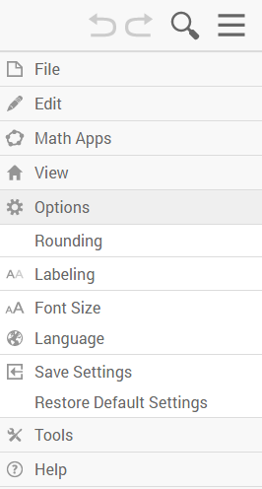
The upper one will allow you to load/save files (via ‘Files’).
‘Options’ is particularly useful.
Check that ‘Rounding’ is set the way you want.
Change ‘Labelling’ to ‘No new objects’?

The lower one allows you to have more than one pane available (eg ‘Algebra’ and ‘Graphics’) – click on the three dots for this.
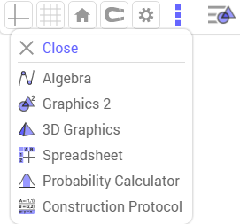
You can make changes to axes, grids and also format objects here.

Using Geometry
The toolbar:
Points: Lines:
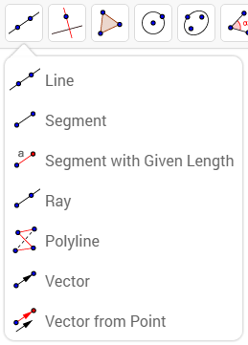
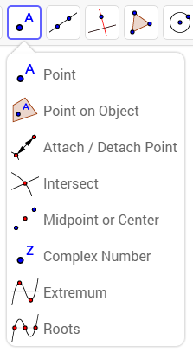
Construction tools: Polygons:
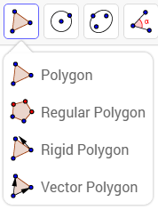
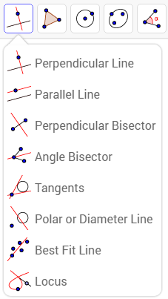
Circles: Conic sections:
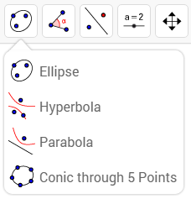
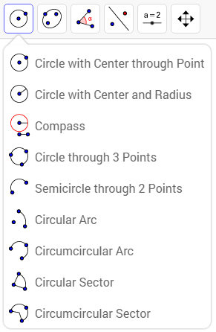
Measurement: Transformations:
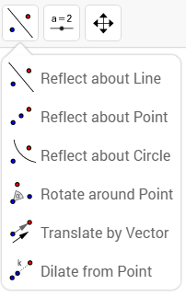
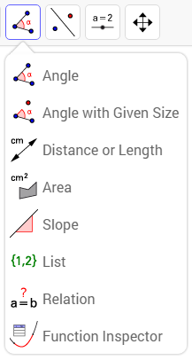

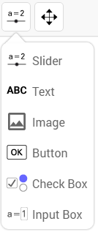
Tools: Moving:
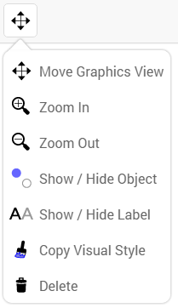

Formatting an object:
